Quinn Smith

W12 Website Planning Document

**City:**

American Falls Idaho!

**Site Purpose:**

To help promote this small towns small businesses! A place where people can go to get information on locally owned and operated businesses. Information about the town will be available as well as having a place to join if people would like to.

**Target Audience:**

Target audience would be people who like to shop, eat, and build up their local town. Also, small business owners or aspiring small business owners. Ages 20-50. Living between American Falls, Aberdeen, and Rockland.

**Site Map:**

**Color Scheme:**

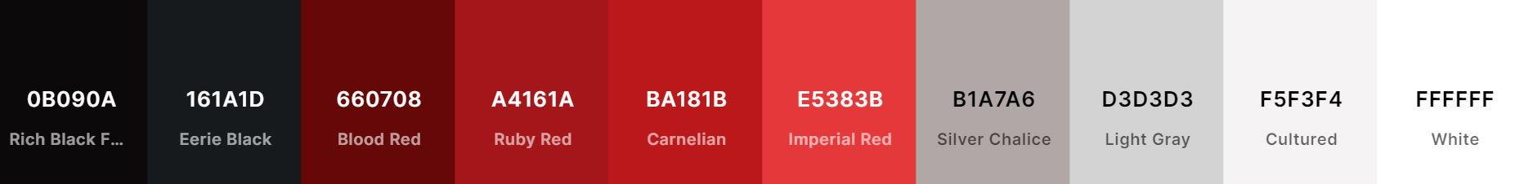

**Typography:**

**Header & Heading Text: Montserrat, San-Serif, Bold**

Paragraph & Navigation Text: Times New Roman, Serif

**Wireframe Sketches:**

large

medium

small